Lab 3: Tableau Basic Functions and Advanced I:

Name: Amisha Farhana Shaik

- Connect tableau to the data:
(1). to the excel file;
(2). to the database/data warehouse: correlate multiple tables;
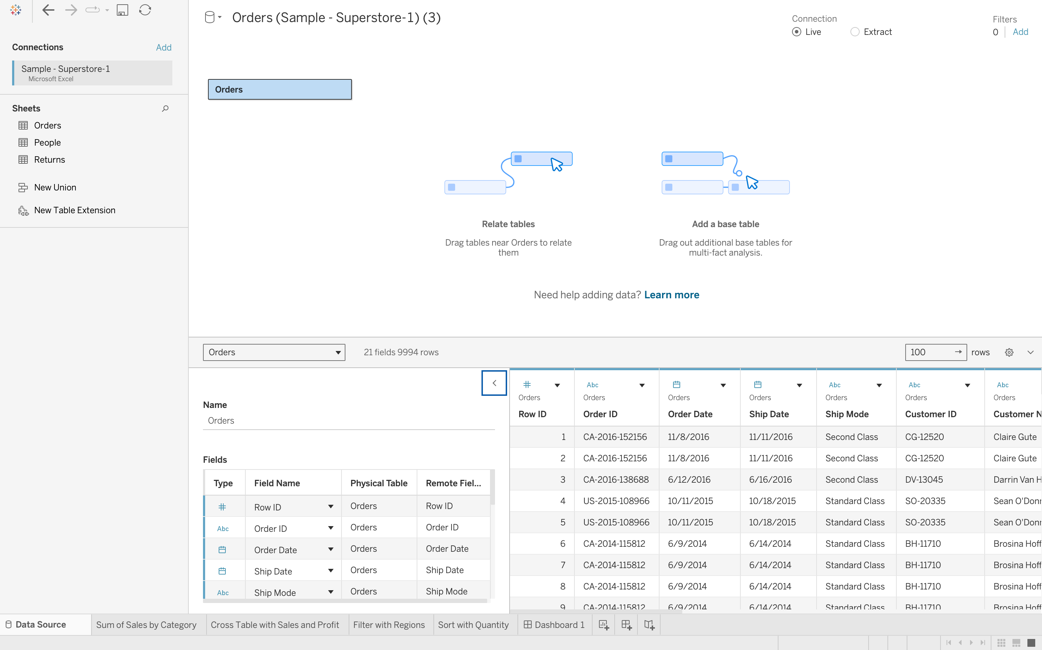

2. Analyze data in the View:
(1). create bar/column charts;
a. Use Category and Sum of the Sales to create a column chart:
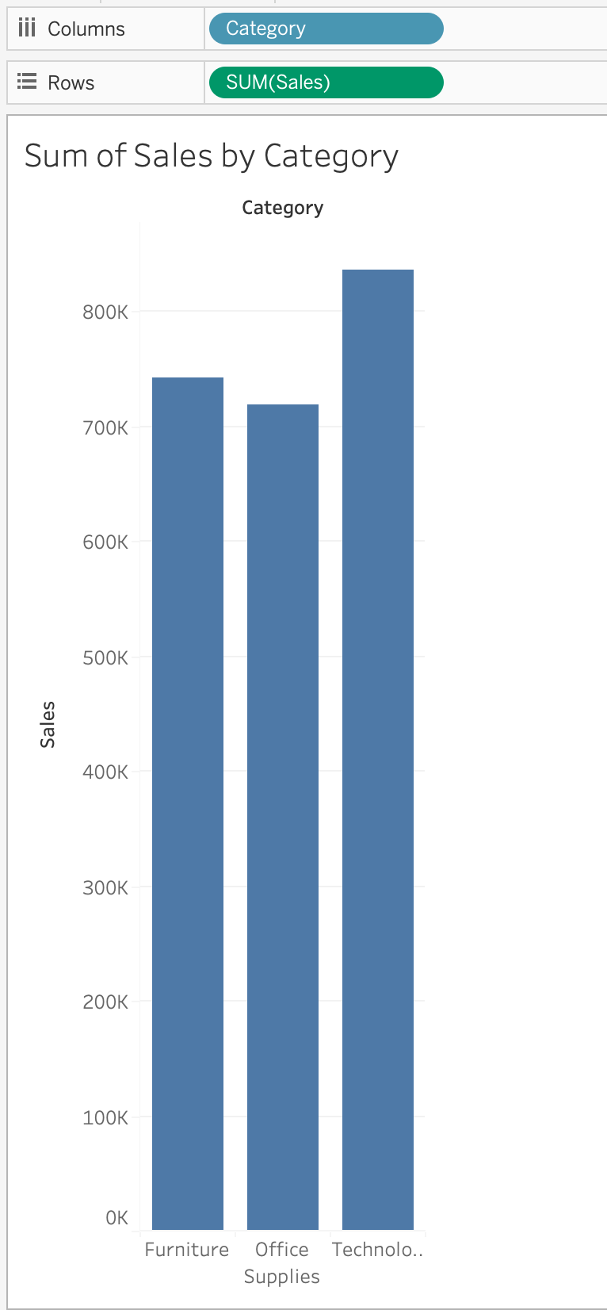
b. Use Category, sub-category and Sum of the Sales to create a bar chart:

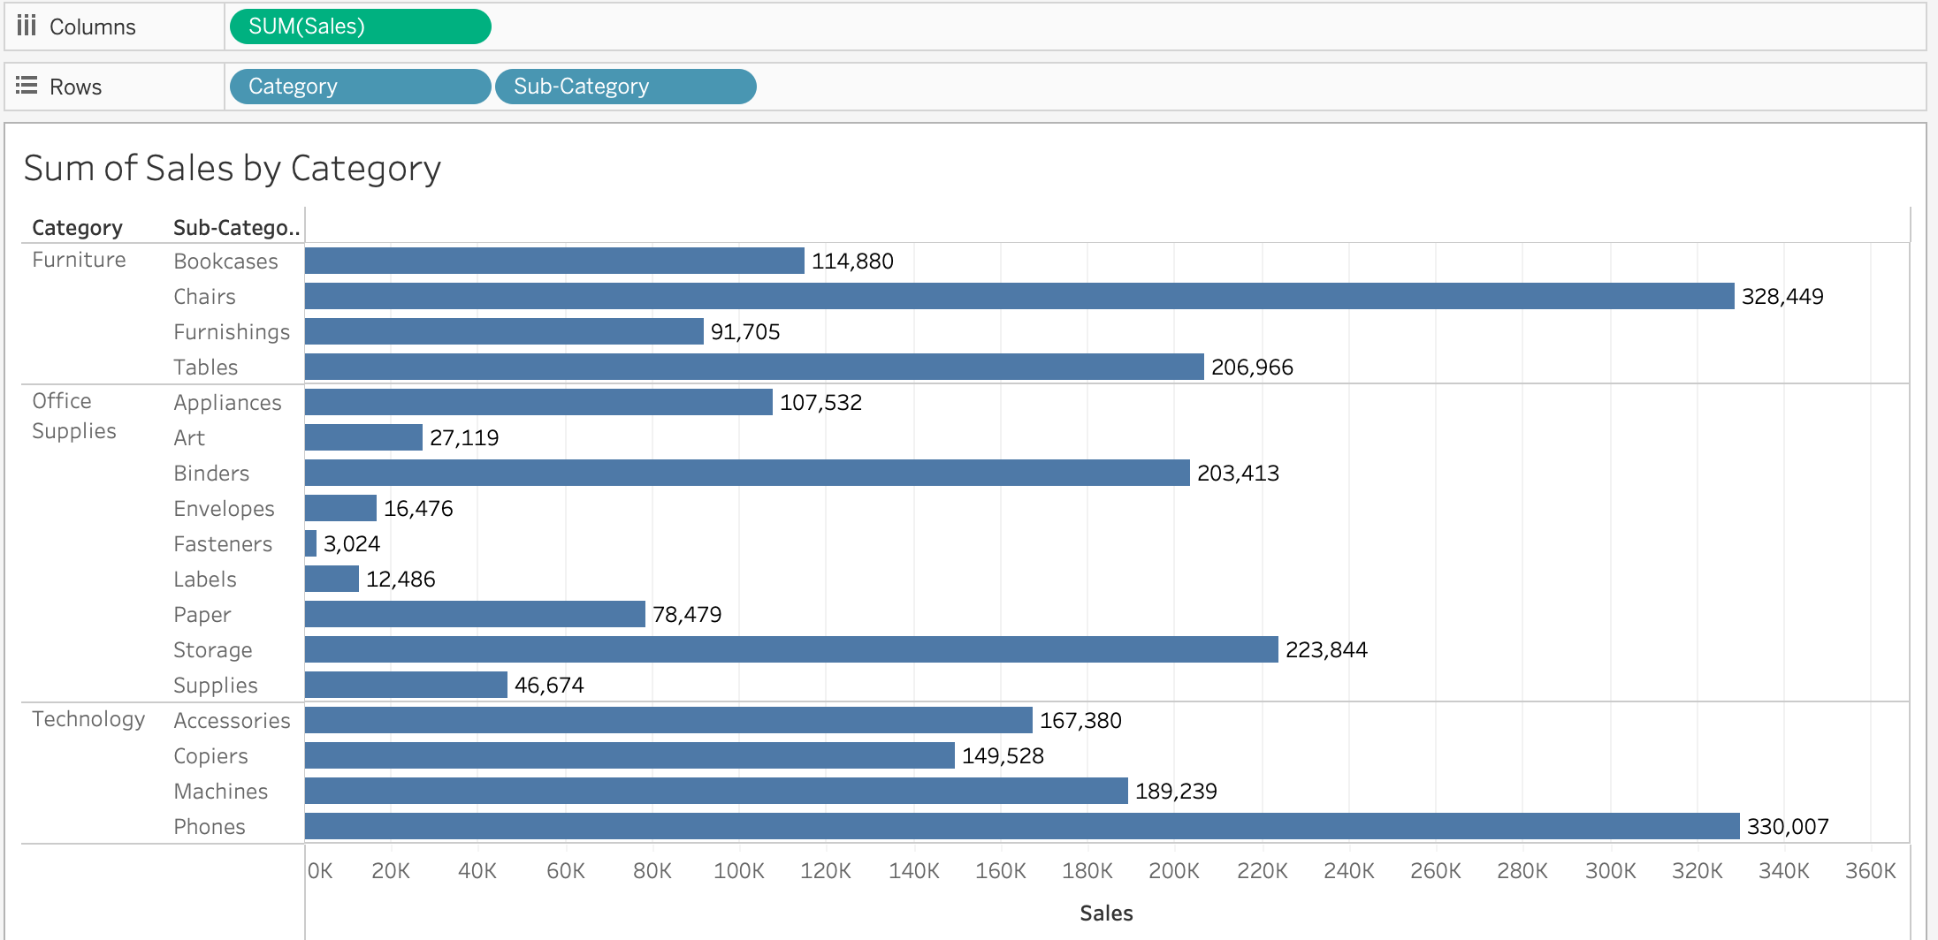
(2). Use additional Measurements (Sum of the Profit) for color comparison:
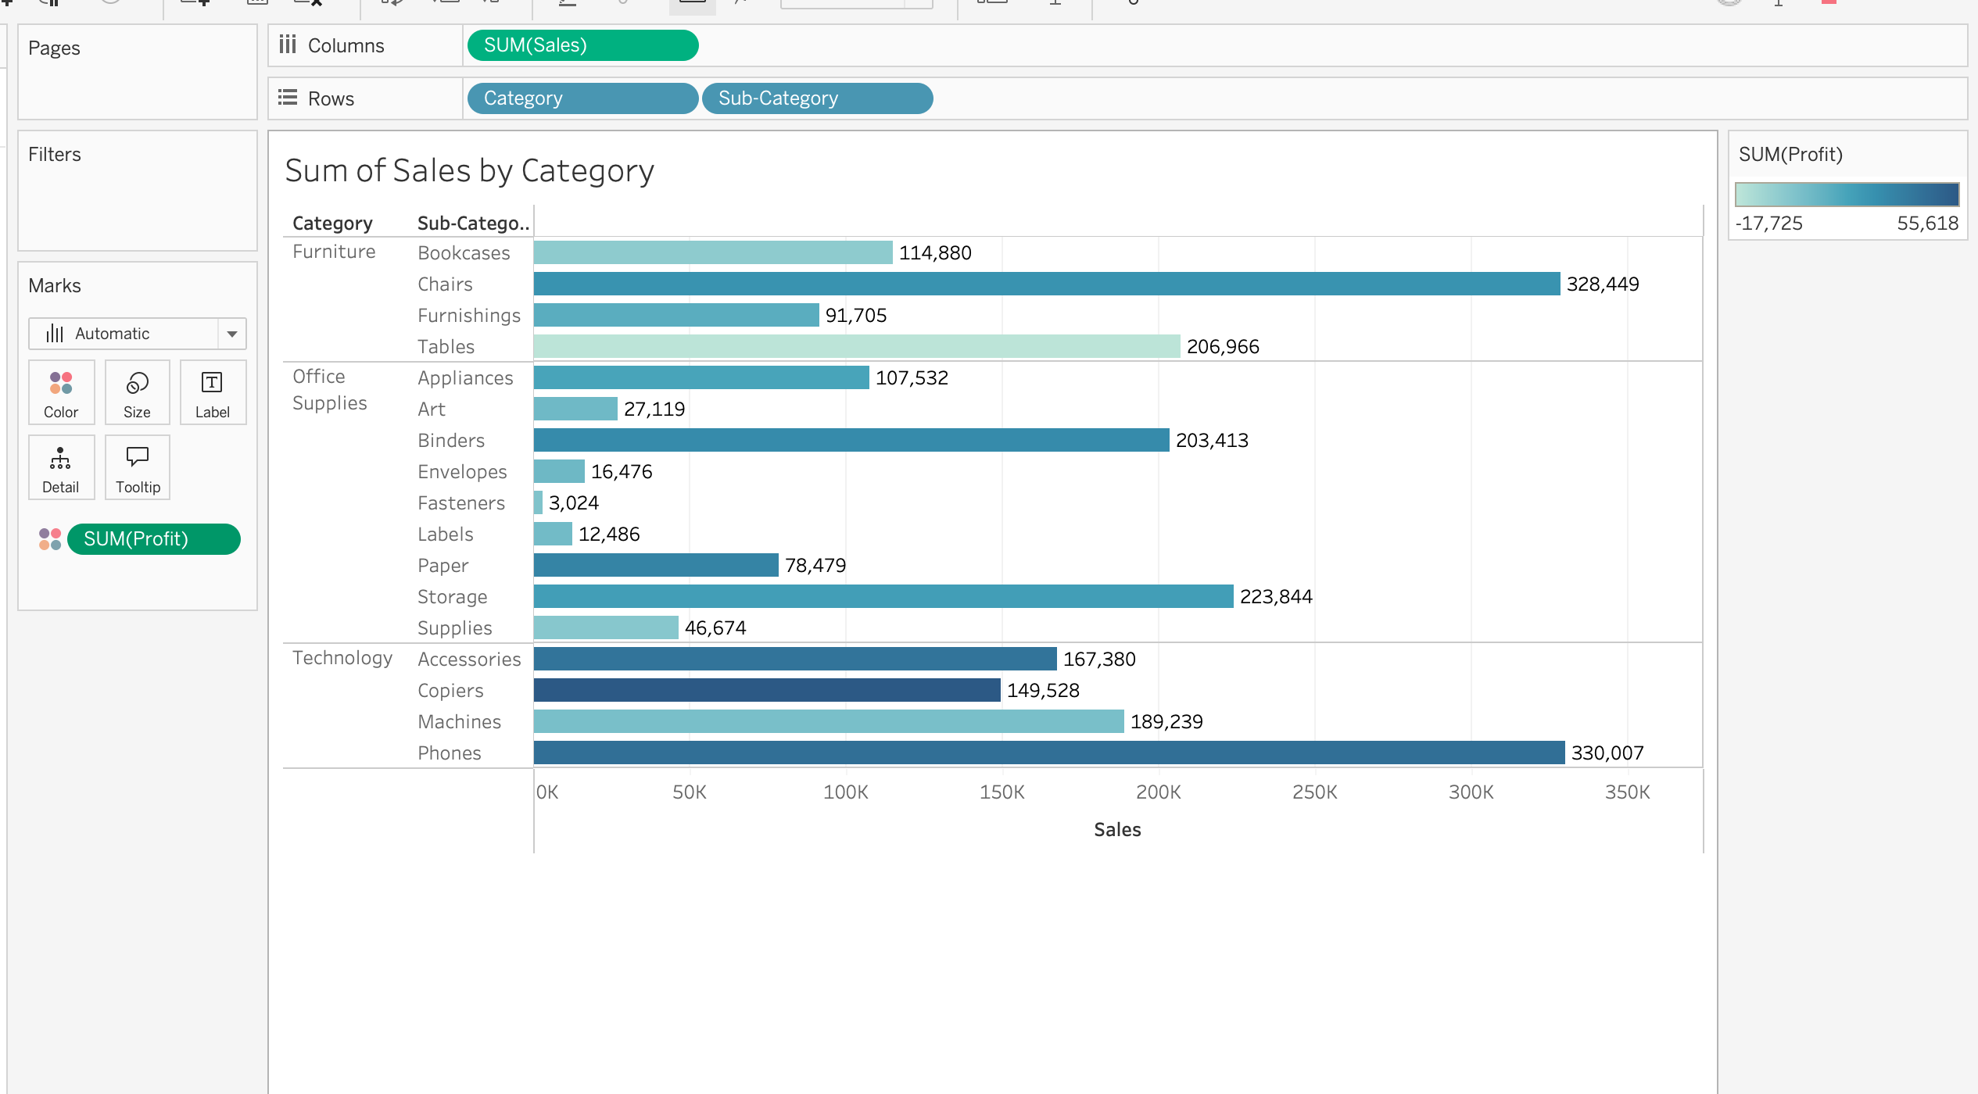
(3). Create cross tables:
a. Use Category, Sub-Category, Sum of the profit, Sum of the sales to create a cross table;
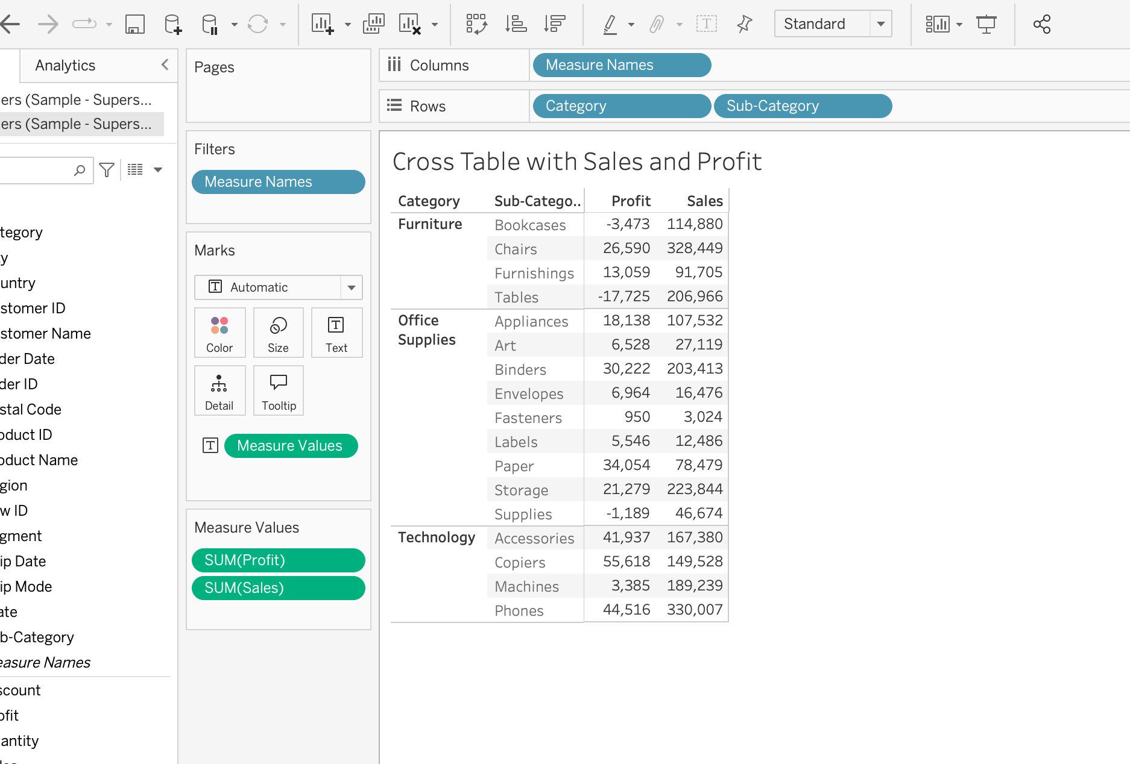
b. Use Sum of all the measurements, Category, and Sub-Category to create a cross table:
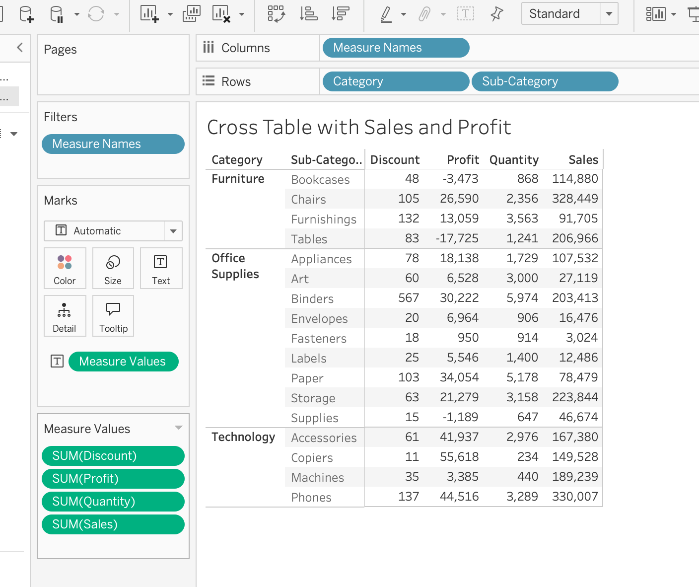

3. Filter the Data:
(1). Filter the categorical dimensions; (category and sub-category)
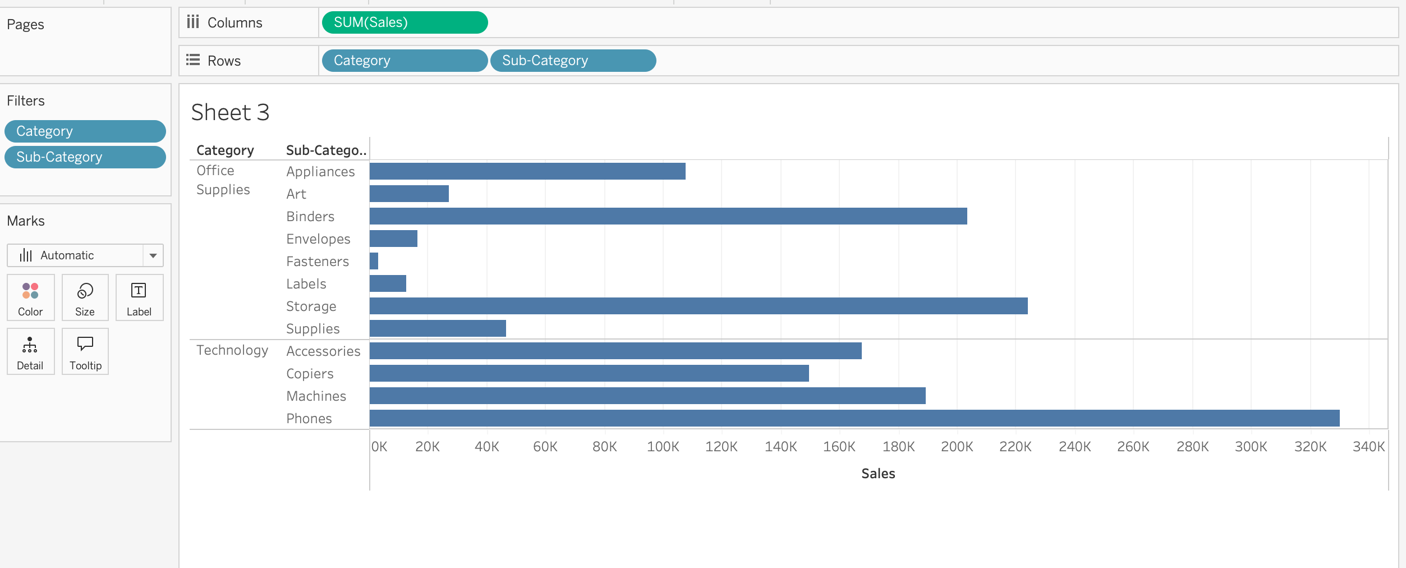
(2). Filter the measurements;

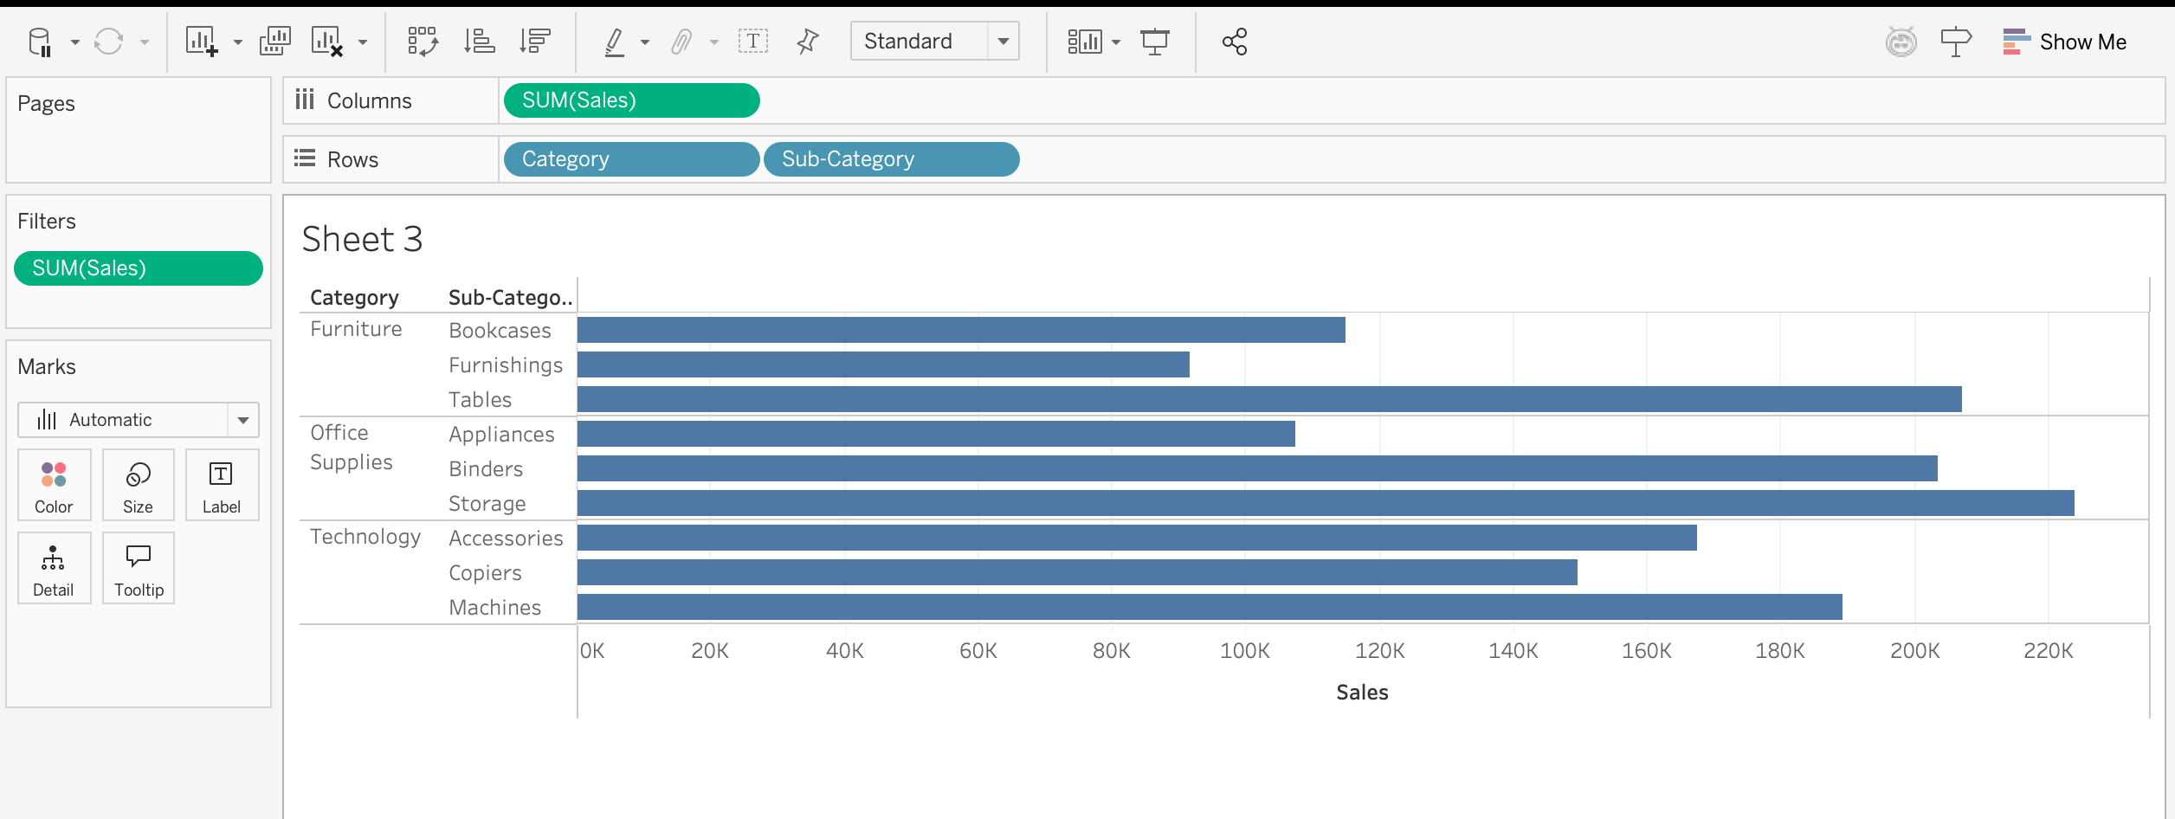
(3). Use Region as the additional Filter option on the side;
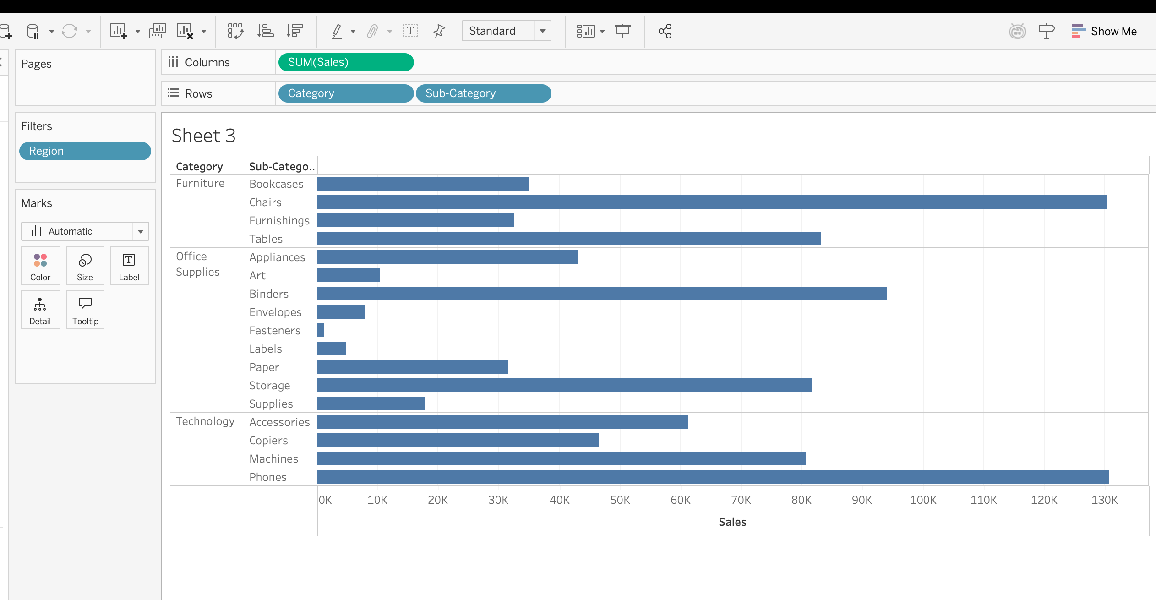

4. Computed Sort and Manual Sort;
(1). Sort bar charts by values;
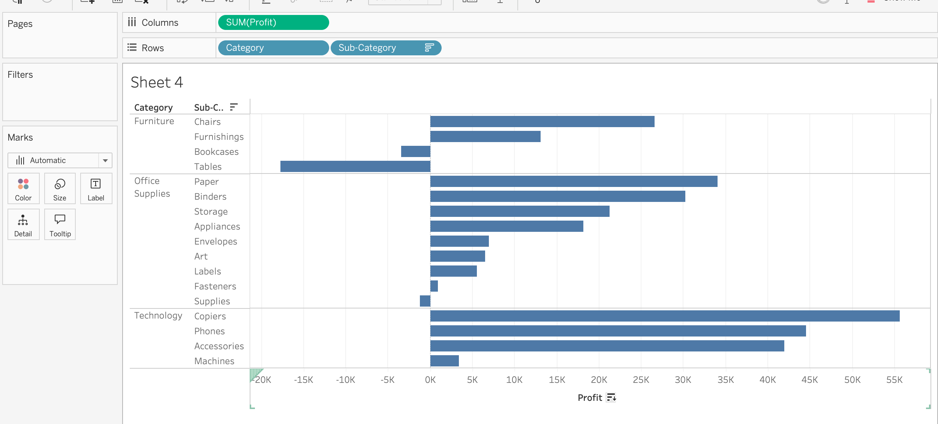

(2). Sort bar charts by two categories;
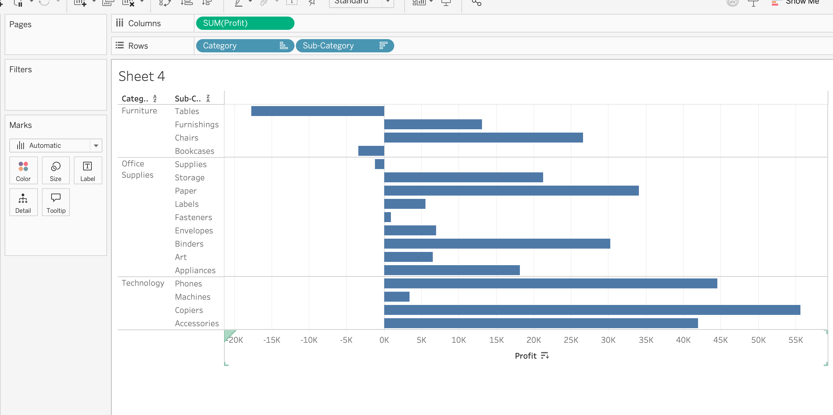
(3). Add additional criteria (Sum of quantity) to the existing sorting;

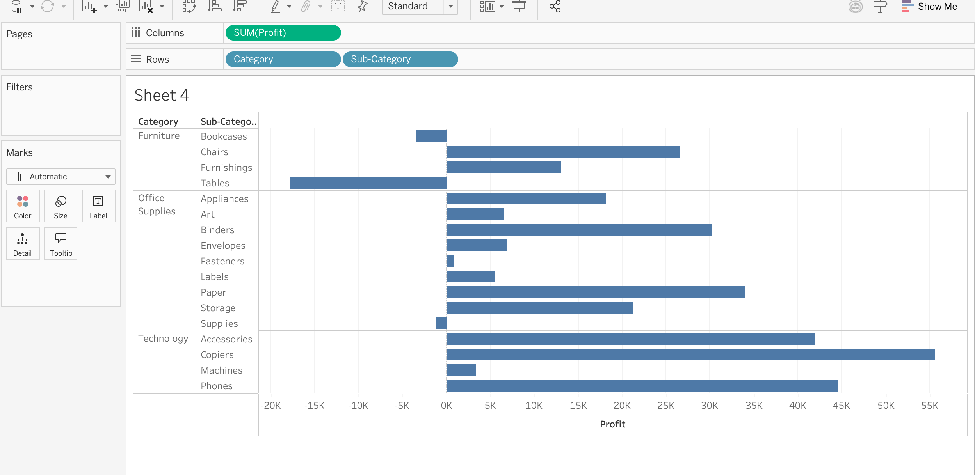
(4). Manual Sorting;

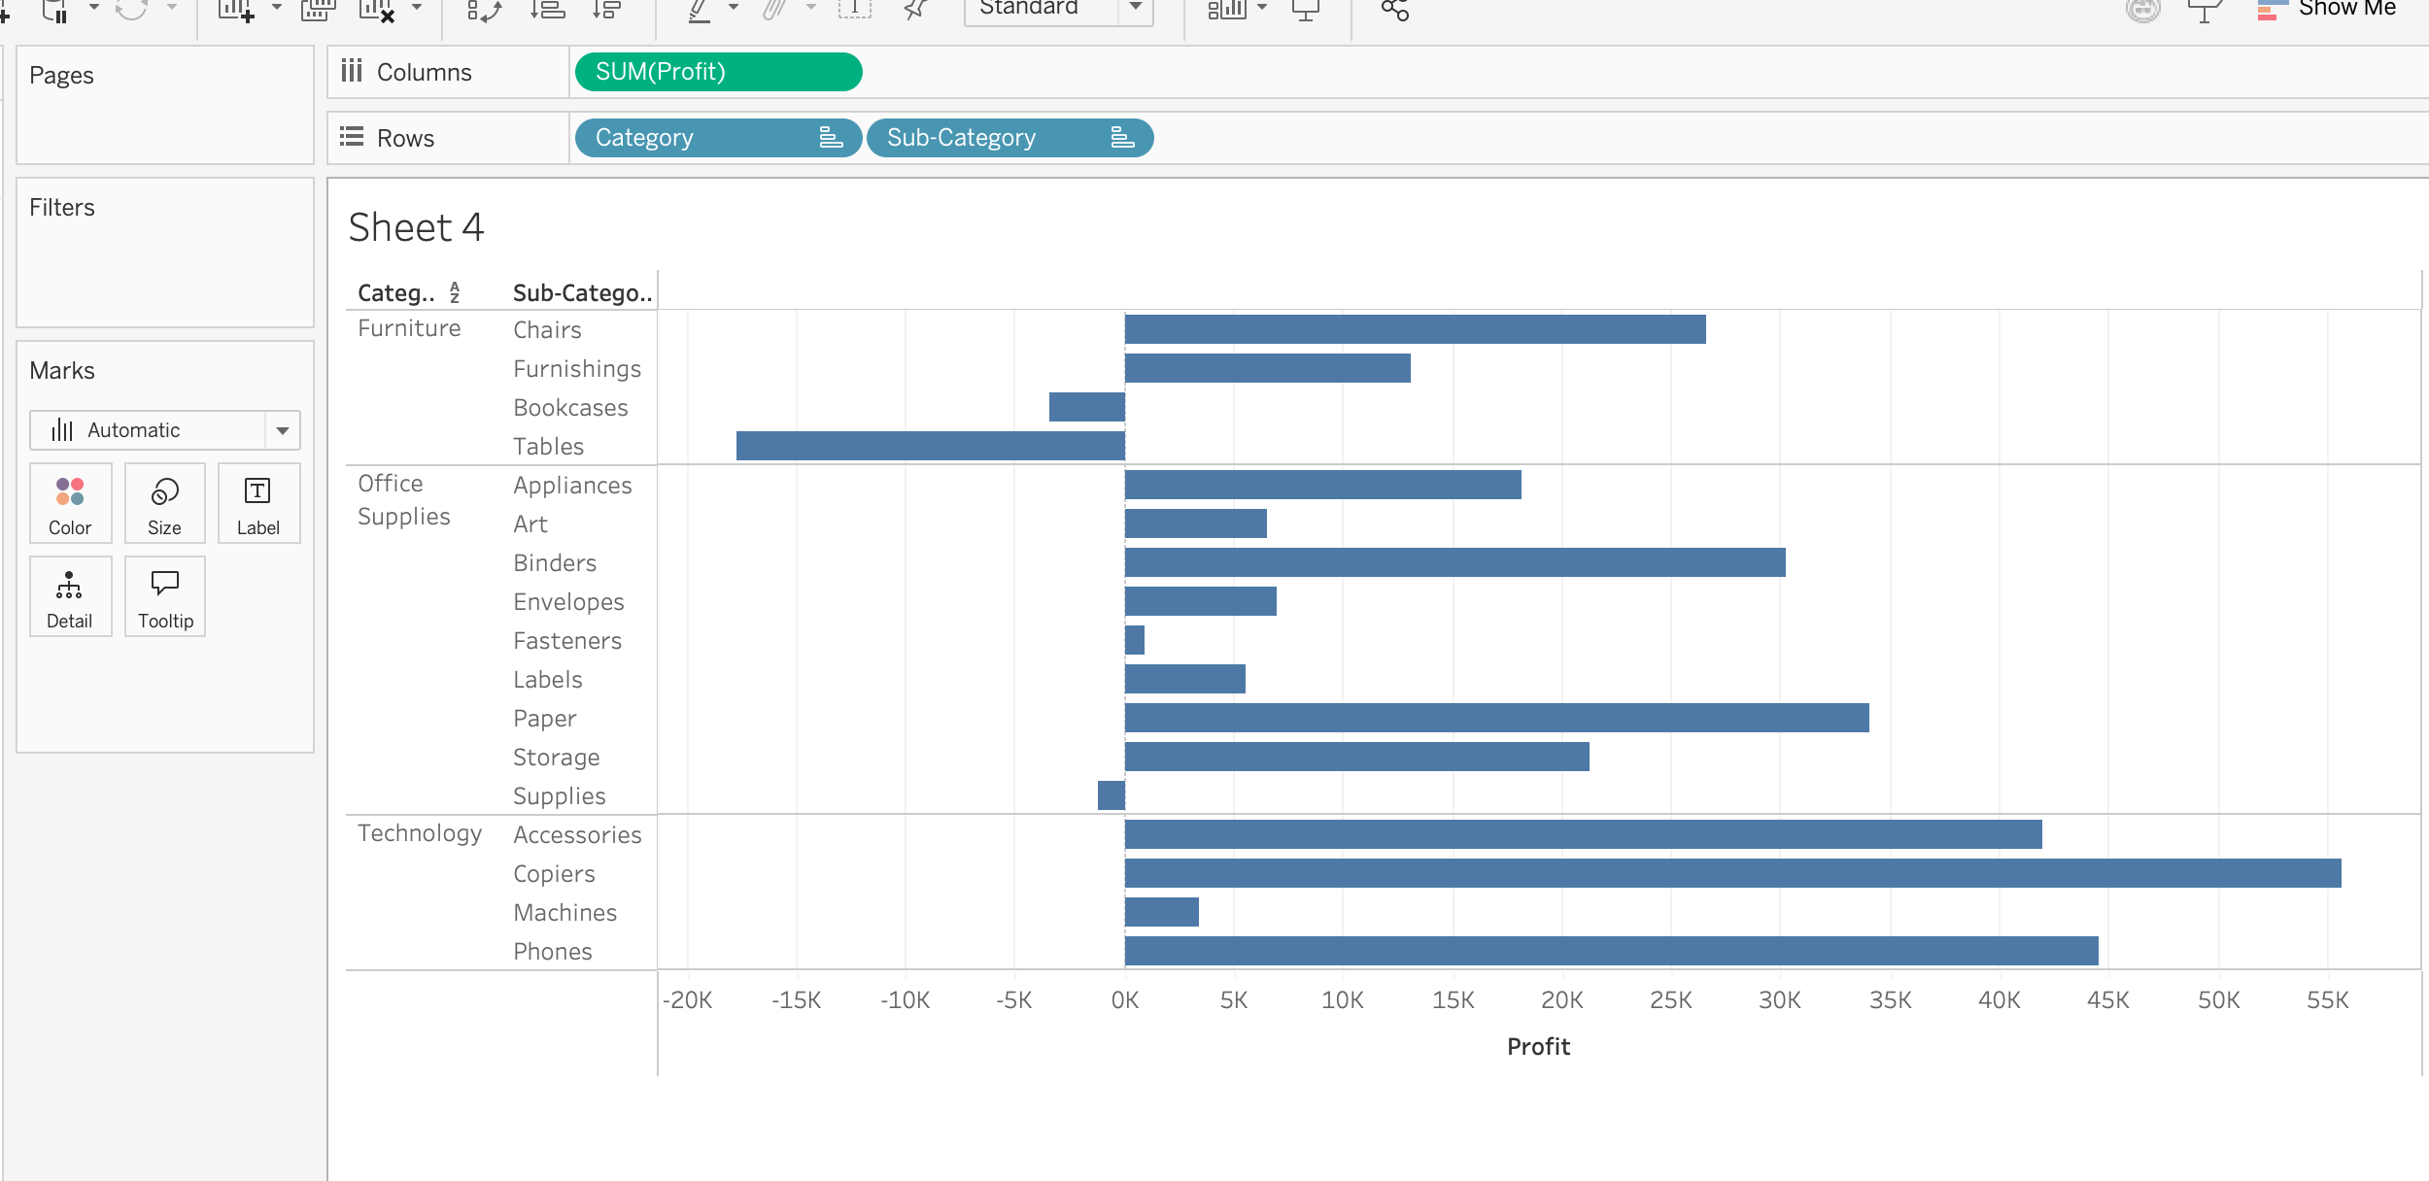

5. Share the views in the dashboard:
(1). Insert views into the dashboard;
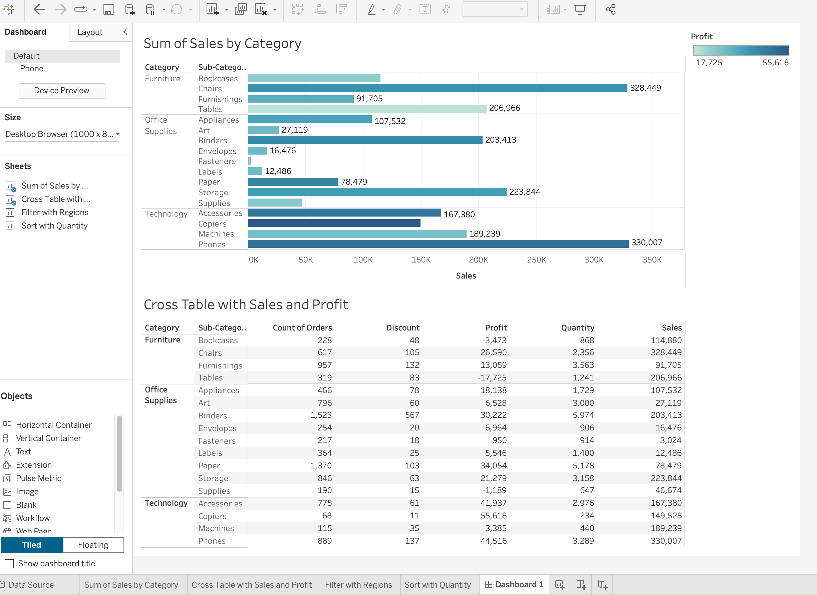
(2). Use one view to filter the other;
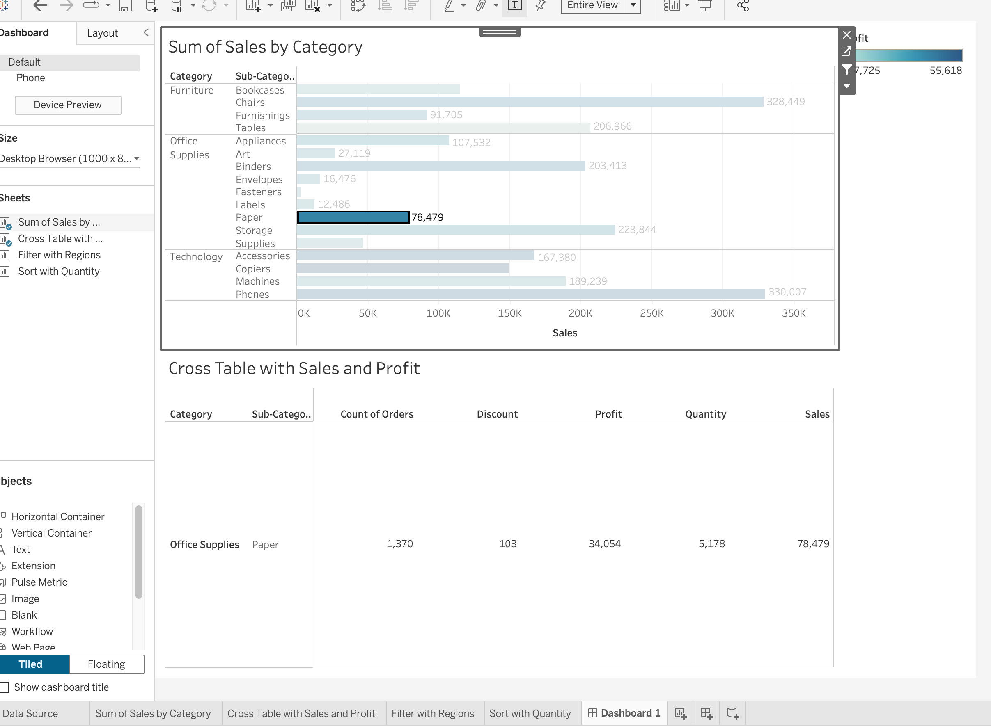
(3). Share and save the dashboard file;
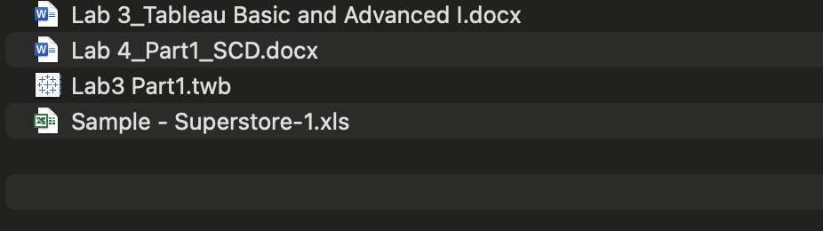

6. Edit and Save a Data Source:
Use the hurricane.xlsx;
(1). Create a folder and assign fields to the folder;
(2). Change dimension to measures, or change measures to dimension (storm #):
(3). Set the default properties of the fields;
(4). Rename a field;
(5). Save the data source locally or to the server;

7. Update the View with New Data:
(1). Live connection;
(2). Automatically change the views by changing data;
(3). Structure change won’t be applied to the views directly;

8. Use Groups to organize Data:
(1). Use Group to categorize Product “Model Name”; Use rename to change the name of the group;
(2). Use Find to discover the keywords for categorization; Use the other to include the remaining items into one group;
(3). Model Sum of Quantity by Model Groups:
(4). Group the items in the View by labels (Use product line and sum of the sales amount):
(5). Compare different groups using bars by different colors (use Size, sum of order quantity):

9. Use Hierarchy to organize data:
(1). Create hierarchy using Customer Information;
(2). Create a bar chart using the Customer hierarchy and Sum of quantity;

10. Working with Discrete and Continuous Date Fields:
(1). Use continuous date field, when you want to view data over time; See the sum of the sales amount of months over year;
(2). Use discrete date field, when you want to view data comparison amongst categories (e.g. month); See the sum of the sales amount of months from different years;
(3). Use different hierarchies and combinations of the date;
(4). Use colors for different months in a year (dimensions and measurements);
(5). Use continuous and discrete date as a filter;
(6). Create custom date: Discrete month and continuous month;

